INTERNET OF THINGS-GROUP 4

SMART PARKING

PHASE-2

STUDENT NAME : R.MUKESH

REGISTER NUMBER : 822621106303

NM ID : aut2282260006

COLLEGE CODE : 8226

COLLEGE NAME : ARIFA INSTITUTE OF

TECHNOLOGY – NAGAI

DEPARTMENT : ELECTRONICS &

COMMUNICATION ENGINEERING

EMAIL ID : mukeshttk9178@gmail.com

SYSTEM ANALYSIS AND DESIGN

**Node Mcu**

The NodeMCU as shown in Fig has assimilated TCP/IP protocol that can give any microcontroller entrance to the Wi-Fi network that supports 2.4 GHz Wi-Fi (802.11 Wi-Fi standards). NodeMCU is capable of either connecting to an existing wireless connection or hosting an application over http protocol. Each Node MCU module comes pre-programmed with an AT command set firmware which means one can simply link this up to your Raspberry Pi device and get about like Wi-Fi shield. The reason why we use node mcu is that it is more cost-efficient with respect to Arduino uno , in Arduino we have to use ethernet shield which provides us secure ethernet connectivity whereas all these features are provided by node mcu and it also comes with a updated feature of wi-fi , where you can power or connect your system by WiFi.

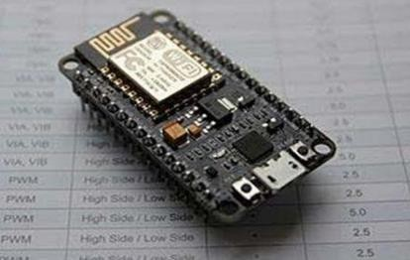

**16*2 LCD Display**

An LCD is an electronic display module which uses liquid crystal to produce a visible image. The 16×2 LCD display is a very basic module commonly used in DIY’s and circuits. The 16×2 translates o a display 16 characters per line in 2 such lines. In this LCD each character is displayed in a 5×7 pixel matrix. The 16*2 display is used to display the number of vacant and spilled spot . It also gets updated on the display LCD when a vehicle parks or unparks the vehicle .

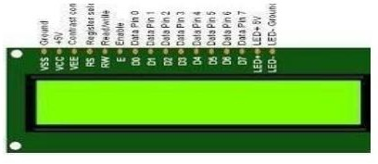

## IR sensor:

An infrared (IR) sensor is an electronic device that measures and detects infrared radiation in its surrounding environment. Infrared radiation was accidentally discovered by an astronomer named William Herchel in 1800. While measuring the temperature of each color of light (separated by a prism), he noticed that the temperature just beyond the red light was highest. IR is invisible to the human eye, as its wavelength is longer than that of visible light (though it is still on the same electromagnetic spectrum). Anything that emits heat (everything that has a temperature above around five degrees Kelvin) gives off infrared radiation. We are using three IR detect sensor in our project , one IR detect sensor is used to sense the vehicle near the parking sensor and other two IR detect sensor is used to send data to the node mcu which is the brain of our system whether a vehicle is parked in that slot or is unparked .

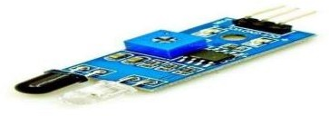

## SYSTEM REQUIREMENTS SPECIFICATION

### Functional Requirement

Functional Requirement defines a function of a software system and how the system must behave when presented with specific inputs/or conditions. These may include calculations, data manipulation and processing and other specific functionality. In these systems following are the functional requirements

* The application should not display in-appropriate message for valid conditions.
* The application must not stop working when kept running for even a long time.
* The application should process information for any kind of input case.
* The application should generate the output for a given input test case .

### Non-Functional Requirement

Non-functional requirements are the requirements which are not directly concerned with the specific function delivered by the system. They specify the criteria that can be used to judge the operation of a system rather than specific behaviours. Given below are the

non-functional requirements:

* Product requirements
* Organizational requirements
* Basic operational requirements

### Hardware Specifications

* ENODE MCU (ESP8266)
* JUMPER WIRES
* INFRARED SENSORS
* 16*2 LED DISPLAY
* DC MOTOR

### Software Specification

* ARDUINO IDE

# System Architecture

The below diagram shows the pin diagram of our model. It consists of one node mcu , one dc motor , one 16*2 LCD display and three IR sensors .The node mcu is the brain of our system which powers all the other devices .The 16*2 LCD display is powered by node mcu by connecting jumper wires from the display to node mcu . The DC motor is also powered by node mcu with connecting its pins to node mcu. The IR sensor consists of three pins, where two pins refer to the power supply and ground and the other pins refer to the pin which is going to be connected in the Node mcu. On successfully connecting all the components in the given figure now we have to connect the blynk app. While using the blynk app we have to specify the widgets used in our android app and the pin number to which they are connected to node mcu in the actual model so that the mobile app will react exactly to the inputs provided in the model .

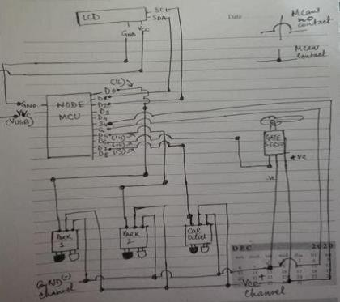

# IMPLEMENTATION

## Flowchart of the System:

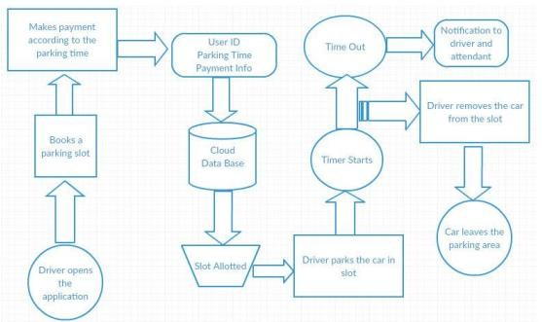

Below are the steps that a driver needs to follow in order to park its car using our parking system.

Step 1: Install the smart parking application on your mobile device. Step 2: On the 16*2 display the number of vacant and filled spots are displayed so that the user can see the status of parking zone. Step 3: Once the user logs into the app he would see the parking architecture with the cars filled at which position and positions which are empty . Step 4: When the user is near to the parking IR detect sensor , he would receive a notification on his app on which slot he can park his vehicle if there is a empty slot. Step 5: If there is no empty slot the user will be displayed with an appropriate message on the mobile application . Step 6: On availability of parking area and user parking into the respective slot he/she would receive a message which states the start time of the parking and the slot in which he/she has parked.

Step 7: On successfully un-parking your vehicle from the parking slot the user will receive a message which states the start time and end time of his parking time and an amount which he needs to pay for the parking duration.

# Design of the System

This model has the capacity of containing two cars. There are two sensors at the entrance to detect the presence of a car before going inside or outside of the parking lot. The other two sensors are plotted inside the parking lot to detect the car individually for each parking slot. A DC Servo motor has been used at the entrance to open and close the gate according to the signals sent by the sensors through Arduino. The projection on the screen corresponds to the system model parking slots. This is a real time display regarding the status of the parking lot. As this is a web-based representation, anyone will be able to get the status of the parking lot by visiting the website on the URL through their cell phones, laptops, desktops and other internet supporting devices. The model of the parking lot has two parking slots. Thus, we can park a maximum number of two cars through the system. We have used two IR sensors which when vehicle parked will show appropriate message to the user and when all the parking slots the dc motor would not open gate for the vehicle to be parked. Displaying of appropriate message for any action which takes place in the parking zone is done effectively and efficiently .

### Network Time protocol :-

The Network Time Protocol is a networking protocol for clock synchronization between computer systems over packet-switched, variable-latency data networks. We have used NTP for fetching time from the NTP server so that we can show the start time and end time for the user when he parks or unparks his vehicle making information real-time.

### Blynk app:-

Blynk app is a hardware-agnostic IoT platform with white label mobile apps, private cloud

,device management, data analytics and machine learning .On using the blynk app we tried to pop notification to every possible event that is occurring in the parking zone . Used a serial algorithm to display the slot number to the user who is going to park his vehicle .For example we display the empty slot number in a serial manner which gets filled , if the slot 1 is filled and when an another vehicle turns up we display slot 2 and further like these for all other vehicles , and if any vehicle leaves the slot number then we display the earlies slot number , not making the user to travel long if an initial spot is vacant .